Road Accidents

ds=read.csv("Road_accidents.csv")  
str(ds)

## 'data.frame': 93 obs. of 17 variables:  
## $ Category : chr "State" "State" "State" "State" ...  
## $ State.UT.City : chr "Andhra Pradesh" "Arunachal Pradesh" "Assam" "Bihar" ...  
## $ National.Highways...Cases : int 8241 110 3197 4348 3658 1069 3376 3525 1075 1263 ...  
## $ National.Highways...Injured: int 8323 112 2560 3536 2885 272 2687 2855 1467 1038 ...  
## $ National.Highways...Died : int 3602 59 1586 3493 1665 93 2017 1846 388 1106 ...  
## $ State.Highways...Cases : int 4704 65 1913 2116 2189 366 4420 1612 399 1364 ...  
## $ State.Highways...Injured : int 4786 77 1516 1928 2083 110 4201 1257 557 775 ...  
## $ State.Highways...Died : int 1904 56 724 1777 1092 32 2543 885 137 1060 ...  
## $ Expressways...Cases : int 0 0 0 0 0 0 44 158 0 0 ...  
## $ Expressways...Injured : int 0 0 0 0 0 0 31 99 0 0 ...  
## $ Expressways...Died : int 0 0 0 0 0 0 33 126 0 0 ...  
## $ Other.Roads...Cases : int 8611 86 1959 3089 6548 1415 7360 4754 934 2101 ...  
## $ Other.Roads...Injured : int 7931 77 1344 2482 5714 474 6803 3761 1421 1414 ...  
## $ Other.Roads...Died : int 2680 58 704 2390 2656 101 2864 2126 507 1347 ...  
## $ Total...Cases : int 21556 261 7069 9553 12395 2850 15200 10049 2408 4728 ...  
## $ Total...Injured : int 21040 266 5420 7946 10682 856 13722 7972 3445 3227 ...  
## $ Total...Died : int 8186 173 3014 7660 5413 226 7457 4983 1032 3513 ...

summary(ds)

## Category State.UT.City National.Highways...Cases  
## Length:93 Length:93 Min. : 0   
## Class :character Class :character 1st Qu.: 99   
## Mode :character Mode :character Median : 238   
## Mean : 4198   
## 3rd Qu.: 1075   
## Max. :122204   
## National.Highways...Injured National.Highways...Died State.Highways...Cases  
## Min. : 0 Min. : 0 Min. : 0   
## 1st Qu.: 55 1st Qu.: 40 1st Qu.: 34   
## Median : 207 Median : 77 Median : 153   
## Mean : 3814 Mean : 1813 Mean : 3266   
## 3rd Qu.: 970 3rd Qu.: 367 3rd Qu.: 729   
## Max. :111786 Max. :53615 Max. :96451   
## State.Highways...Injured State.Highways...Died Expressways...Cases  
## Min. : 0 Min. : 0 Min. : 0.00   
## 1st Qu.: 15 1st Qu.: 15 1st Qu.: 0.00   
## Median : 112 Median : 37 Median : 0.00   
## Mean : 3107 Mean : 1298 Mean : 65.62   
## 3rd Qu.: 775 3rd Qu.: 172 3rd Qu.: 2.00   
## Max. :92171 Max. :39040 Max. :1899.00   
## Expressways...Injured Expressways...Died Other.Roads...Cases  
## Min. : 0.00 Min. : 0.00 Min. : 2   
## 1st Qu.: 0.00 1st Qu.: 0.00 1st Qu.: 179   
## Median : 0.00 Median : 0.00 Median : 551   
## Mean : 41.96 Mean : 46.09 Mean : 6666   
## 3rd Qu.: 0.00 3rd Qu.: 1.00 3rd Qu.: 2450   
## Max. :1214.00 Max. :1356.00 Max. :182562   
## Other.Roads...Injured Other.Roads...Died Total...Cases Total...Injured   
## Min. : 1 Min. : 0 Min. : 4 Min. : 6   
## 1st Qu.: 113 1st Qu.: 53 1st Qu.: 352 1st Qu.: 266   
## Median : 474 Median : 118 Median : 1049 Median : 856   
## Mean : 6056 Mean : 2151 Mean : 14196 Mean : 13018   
## 3rd Qu.: 2085 3rd Qu.: 715 3rd Qu.: 4728 3rd Qu.: 3827   
## Max. :166713 Max. :61611 Max. :403116 Max. :371884   
## Total...Died   
## Min. : 1   
## 1st Qu.: 131   
## Median : 226   
## Mean : 5308   
## 3rd Qu.: 1172   
## Max. :155622

#Dataset Subsetting  
library(dplyr)

##   
## Attaching package: 'dplyr'

## The following objects are masked from 'package:stats':  
##   
## filter, lag

## The following objects are masked from 'package:base':  
##   
## intersect, setdiff, setequal, union

head(ds)

## Category State.UT.City National.Highways...Cases  
## 1 State Andhra Pradesh 8241  
## 2 State Arunachal Pradesh 110  
## 3 State Assam 3197  
## 4 State Bihar 4348  
## 5 State Chhattisgarh 3658  
## 6 State Goa 1069  
## National.Highways...Injured National.Highways...Died State.Highways...Cases  
## 1 8323 3602 4704  
## 2 112 59 65  
## 3 2560 1586 1913  
## 4 3536 3493 2116  
## 5 2885 1665 2189  
## 6 272 93 366  
## State.Highways...Injured State.Highways...Died Expressways...Cases  
## 1 4786 1904 0  
## 2 77 56 0  
## 3 1516 724 0  
## 4 1928 1777 0  
## 5 2083 1092 0  
## 6 110 32 0  
## Expressways...Injured Expressways...Died Other.Roads...Cases  
## 1 0 0 8611  
## 2 0 0 86  
## 3 0 0 1959  
## 4 0 0 3089  
## 5 0 0 6548  
## 6 0 0 1415  
## Other.Roads...Injured Other.Roads...Died Total...Cases Total...Injured  
## 1 7931 2680 21556 21040  
## 2 77 58 261 266  
## 3 1344 704 7069 5420  
## 4 2482 2390 9553 7946  
## 5 5714 2656 12395 10682  
## 6 474 101 2850 856  
## Total...Died  
## 1 8186  
## 2 173  
## 3 3014  
## 4 7660  
## 5 5413  
## 6 226

sample_n(ds,20)

## Category State.UT.City National.Highways...Cases  
## 1 UT Total (UTs) 3232  
## 2 City Dhanbad 107  
## 3 City Srinagar 99  
## 4 State Kerala 7806  
## 5 UT Lakshadweep 0  
## 6 City Nasik 0  
## 7 City Ghaziabad 142  
## 8 Total (All India) Total (All India) 122204  
## 9 City Ranchi 0  
## 10 State Andhra Pradesh 8241  
## 11 City Kozhikode 458  
## 12 City Agra 60  
## 13 City Bhopal 53  
## 14 State West Bengal 3633  
## 15 City Thrissur 209  
## 16 City Jabalpur 612  
## 17 City Kannur 248  
## 18 City Ludhiana 168  
## 19 City Kolkata 14  
## 20 City Jaipur 581  
## National.Highways...Injured National.Highways...Died State.Highways...Cases  
## 1 3449 776 1392  
## 2 55 73 52  
## 3 102 14 0  
## 4 8716 1021 8103  
## 5 0 0 0  
## 6 0 0 13  
## 7 111 47 37  
## 8 111786 53615 96451  
## 9 0 0 0  
## 10 8323 3602 4704  
## 11 453 67 211  
## 12 7 64 14  
## 13 53 8 331  
## 14 3232 2111 2412  
## 15 225 49 729  
## 16 514 53 646  
## 17 270 31 245  
## 18 53 140 43  
## 19 0 16 24  
## 20 450 254 111  
## State.Highways...Injured State.Highways...Died Expressways...Cases  
## 1 1618 304 10  
## 2 40 38 0  
## 3 0 0 0  
## 4 9217 877 0  
## 5 0 0 0  
## 6 8 14 0  
## 7 15 25 69  
## 8 92171 39040 1899  
## 9 0 0 0  
## 10 4786 1904 0  
## 11 214 17 0  
## 12 15 14 0  
## 13 331 10 0  
## 14 2096 1400 127  
## 15 777 83 0  
## 16 523 80 0  
## 17 423 33 0  
## 18 11 42 0  
## 19 9 15 0  
## 20 112 37 29  
## Expressways...Injured Expressways...Died Other.Roads...Cases  
## 1 3 6 7243  
## 2 0 0 28  
## 3 0 0 232  
## 4 0 0 16850  
## 5 0 0 4  
## 6 0 0 129  
## 7 50 24 48  
## 8 1214 1356 182562  
## 9 0 0 183  
## 10 0 0 8611  
## 11 0 0 708  
## 12 0 0 86  
## 13 0 0 1507  
## 14 79 41 5329  
## 15 0 0 781  
## 16 0 0 544  
## 17 0 0 617  
## 18 0 0 267  
## 19 0 0 1481  
## 20 12 18 1445  
## Other.Roads...Injured Other.Roads...Died Total...Cases Total...Injured  
## 1 7611 1351 11877 12681  
## 2 13 12 187 108  
## 3 245 26 331 347  
## 4 18581 1531 32759 36514  
## 5 6 1 4 6  
## 6 14 128 142 22  
## 7 43 33 296 219  
## 8 166713 61611 403116 371884  
## 9 129 102 183 129  
## 10 7931 2680 21556 21040  
## 11 724 47 1377 1391  
## 12 31 88 160 53  
## 13 1194 86 1891 1578  
## 14 4389 2279 11501 9796  
## 15 873 69 1719 1875  
## 16 915 90 1802 1952  
## 17 634 58 1110 1327  
## 18 105 198 478 169  
## 19 1316 180 1519 1325  
## 20 1217 316 2166 1791  
## Total...Died  
## 1 2437  
## 2 123  
## 3 40  
## 4 3429  
## 5 1  
## 6 142  
## 7 129  
## 8 155622  
## 9 102  
## 10 8186  
## 11 131  
## 12 166  
## 13 104  
## 14 5831  
## 15 201  
## 16 223  
## 17 122  
## 18 380  
## 19 211  
## 20 625

#Subset of States  
ds1=filter(ds,Category=="State")  
ds1

## Category State.UT.City National.Highways...Cases  
## 1 State Andhra Pradesh 8241  
## 2 State Arunachal Pradesh 110  
## 3 State Assam 3197  
## 4 State Bihar 4348  
## 5 State Chhattisgarh 3658  
## 6 State Goa 1069  
## 7 State Gujarat 3376  
## 8 State Haryana 3525  
## 9 State Himachal Pradesh 1075  
## 10 State Jharkhand 1263  
## 11 State Karnataka 11482  
## 12 State Kerala 7806  
## 13 State Madhya Pradesh 10233  
## 14 State Maharashtra 6976  
## 15 State Manipur 236  
## 16 State Meghalaya 141  
## 17 State Mizoram 24  
## 18 State Nagaland 12  
## 19 State Odisha 4038  
## 20 State Punjab 1898  
## 21 State Rajasthan 6378  
## 22 State Sikkim 47  
## 23 State Tamil Nadu 17074  
## 24 State Telangana 7200  
## 25 State Tripura 199  
## 26 State Uttar Pradesh 11168  
## 27 State Uttarakhand 565  
## 28 State West Bengal 3633  
## 29 State Total (States) 118972  
## National.Highways...Injured National.Highways...Died State.Highways...Cases  
## 1 8323 3602 4704  
## 2 112 59 65  
## 3 2560 1586 1913  
## 4 3536 3493 2116  
## 5 2885 1665 2189  
## 6 272 93 366  
## 7 2687 2017 4420  
## 8 2855 1846 1612  
## 9 1467 388 399  
## 10 1038 1106 1364  
## 11 13367 3490 8812  
## 12 8716 1021 8103  
## 13 9922 3287 11155  
## 14 5330 3996 6885  
## 15 322 76 75  
## 16 161 118 47  
## 17 10 23 29  
## 18 5 10 11  
## 19 3533 1888 2338  
## 20 970 1545 2015  
## 21 5884 3653 3666  
## 22 45 23 46  
## 23 17377 5360 18560  
## 24 6911 2732 2192  
## 25 207 94 171  
## 26 6150 7212 9170  
## 27 460 345 224  
## 28 3232 2111 2412  
## 29 108337 52839 95059  
## State.Highways...Injured State.Highways...Died Expressways...Cases  
## 1 4786 1904 0  
## 2 77 56 0  
## 3 1516 724 0  
## 4 1928 1777 0  
## 5 2083 1092 0  
## 6 110 32 0  
## 7 4201 2543 44  
## 8 1257 885 158  
## 9 557 137 0  
## 10 775 1060 0  
## 11 11534 2758 0  
## 12 9217 877 0  
## 13 11332 3088 0  
## 14 5439 3807 199  
## 15 99 21 0  
## 16 41 32 0  
## 17 11 30 0  
## 18 29 11 0  
## 19 2157 1070 47  
## 20 995 1445 107  
## 21 3455 1912 29  
## 22 71 20 0  
## 23 18835 5067 7  
## 24 2075 864 14  
## 25 243 61 0  
## 26 5402 5891 1157  
## 27 232 172 0  
## 28 2096 1400 127  
## 29 90553 38736 1889  
## Expressways...Injured Expressways...Died Other.Roads...Cases  
## 1 0 0 8611  
## 2 0 0 86  
## 3 0 0 1959  
## 4 0 0 3089  
## 5 0 0 6548  
## 6 0 0 1415  
## 7 31 33 7360  
## 8 99 126 4754  
## 9 0 0 934  
## 10 0 0 2101  
## 11 0 0 14353  
## 12 0 0 16850  
## 13 0 0 26831  
## 14 130 87 12538  
## 15 0 0 55  
## 16 0 0 56  
## 17 0 0 11  
## 18 0 0 2  
## 19 24 32 4560  
## 20 64 43 2077  
## 21 12 18 10881  
## 22 0 0 29  
## 23 7 2 20041  
## 24 16 3 11909  
## 25 0 0 108  
## 26 749 965 12216  
## 27 0 0 616  
## 28 79 41 5329  
## 29 1211 1350 175319  
## Other.Roads...Injured Other.Roads...Died Total...Cases Total...Injured  
## 1 7931 2680 21556 21040  
## 2 77 58 261 266  
## 3 1344 704 7069 5420  
## 4 2482 2390 9553 7946  
## 5 5714 2656 12395 10682  
## 6 474 101 2850 856  
## 7 6803 2864 15200 13722  
## 8 3761 2126 10049 7972  
## 9 1421 507 2408 3445  
## 10 1414 1347 4728 3227  
## 11 15853 3790 34647 40754  
## 12 18581 1531 32759 36514  
## 13 25863 6105 48219 47117  
## 14 8777 6021 26598 19676  
## 15 83 13 366 504  
## 16 61 37 244 263  
## 17 7 11 64 28  
## 18 1 2 25 35  
## 19 4068 2091 10983 9782  
## 20 1005 1483 6097 3034  
## 21 10006 4460 20954 19357  
## 22 62 21 122 178  
## 23 19777 4955 55682 55996  
## 24 11105 3958 21315 20107  
## 25 96 39 478 546  
## 26 7512 7724 33711 19813  
## 27 435 307 1405 1127  
## 28 4389 2279 11501 9796  
## 29 159102 60260 391239 359203  
## Total...Died  
## 1 8186  
## 2 173  
## 3 3014  
## 4 7660  
## 5 5413  
## 6 226  
## 7 7457  
## 8 4983  
## 9 1032  
## 10 3513  
## 11 10038  
## 12 3429  
## 13 12480  
## 14 13911  
## 15 110  
## 16 187  
## 17 64  
## 18 23  
## 19 5081  
## 20 4516  
## 21 10043  
## 22 64  
## 23 15384  
## 24 7557  
## 25 194  
## 26 21792  
## 27 824  
## 28 5831  
## 29 153185

#Data preprocessing of ds1  
library(caret)

## Loading required package: ggplot2

## Loading required package: lattice

n_ds <- preProcess(as.data.frame(ds1), method=c("range"))  
ds1 <- predict(n_ds, as.data.frame(ds1))  
  
summary(ds1)

## Category State.UT.City National.Highways...Cases  
## Length:29 Length:29 Min. :0.000000   
## Class :character Class :character 1st Qu.:0.004649   
## Mode :character Mode :character Median :0.029531   
## Mean :0.068872   
## 3rd Qu.:0.060424   
## Max. :1.000000   
## National.Highways...Injured National.Highways...Died State.Highways...Cases  
## Min. :0.000000 Min. :0.000000 Min. :0.000000   
## 1st Qu.:0.002926 1st Qu.:0.002044 1st Qu.:0.002241   
## Median :0.026308 Median :0.031328 Median :0.022147   
## Mean :0.068922 Mean :0.068789 Mean :0.068858   
## 3rd Qu.:0.056724 3rd Qu.:0.065873 3rd Qu.:0.049375   
## Max. :1.000000 Max. :1.000000 Max. :1.000000   
## State.Highways...Injured State.Highways...Died Expressways...Cases  
## Min. :0.000000 Min. :0.000000 Min. :0.00000   
## 1st Qu.:0.002441 1st Qu.:0.001291 1st Qu.:0.00000   
## Median :0.021173 Median :0.027088 Median :0.00000   
## Mean :0.068852 Mean :0.068701 Mean :0.06897   
## 3rd Qu.:0.052738 3rd Qu.:0.049090 3rd Qu.:0.02329   
## Max. :1.000000 Max. :1.000000 Max. :1.00000   
## Expressways...Injured Expressways...Died Other.Roads...Cases  
## Min. :0.00000 Min. :0.00000 Min. :0.000000   
## 1st Qu.:0.00000 1st Qu.:0.00000 1st Qu.:0.003502   
## Median :0.00000 Median :0.00000 Median :0.025999   
## Mean :0.06897 Mean :0.06897 Mean :0.068955   
## 3rd Qu.:0.01982 3rd Qu.:0.02370 3rd Qu.:0.067917   
## Max. :1.00000 Max. :1.00000 Max. :1.000000   
## Other.Roads...Injured Other.Roads...Died Total...Cases Total...Injured   
## Min. :0.000000 Min. :0.000000 Min. :0.000000 Min. :0.000000   
## 1st Qu.:0.002728 1st Qu.:0.001643 1st Qu.:0.003527 1st Qu.:0.002305   
## Median :0.023633 Median :0.034668 Median :0.025623 Median :0.022117   
## Mean :0.068960 Mean :0.068935 Mean :0.068906 Mean :0.068893   
## 3rd Qu.:0.055160 3rd Qu.:0.062863 3rd Qu.:0.055036 3rd Qu.:0.055085   
## Max. :1.000000 Max. :1.000000 Max. :1.000000 Max. :1.000000   
## Total...Died   
## Min. :0.000000   
## 1st Qu.:0.001325   
## Median :0.032384   
## Mean :0.068826   
## 3rd Qu.:0.053296   
## Max. :1.000000

library(lattice)  
#Histograms for States  
histogram(~Total...Cases,data=ds1,breaks=50)

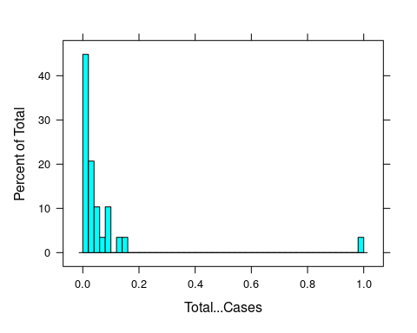

histogram(~Total...Injured,data=ds1,breaks=50)

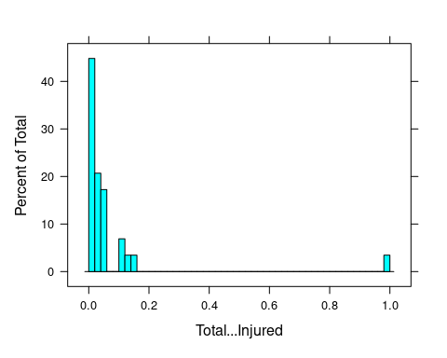

histogram(~Total...Died,data=ds1,breaks=50)

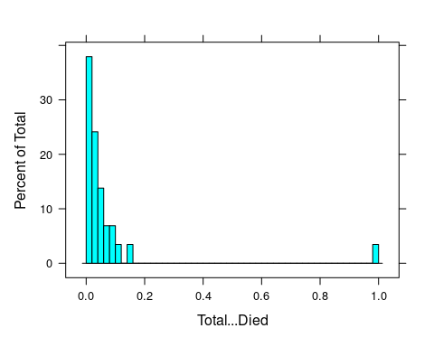

#Barplot for States  
bp1=ds1[-c(29), ]  
  
names(bp1)

## [1] "Category" "State.UT.City"   
## [3] "National.Highways...Cases" "National.Highways...Injured"  
## [5] "National.Highways...Died" "State.Highways...Cases"   
## [7] "State.Highways...Injured" "State.Highways...Died"   
## [9] "Expressways...Cases" "Expressways...Injured"   
## [11] "Expressways...Died" "Other.Roads...Cases"   
## [13] "Other.Roads...Injured" "Other.Roads...Died"   
## [15] "Total...Cases" "Total...Injured"   
## [17] "Total...Died"

barplot(bp1$Total...Cases,  
 ylim = c(0,1),  
 names.arg = bp1$ State.UT.City,  
 las = 2,cex.names =0.6,main="Total cases in States",  
 xlab = "States",ylab = "no.of cases")

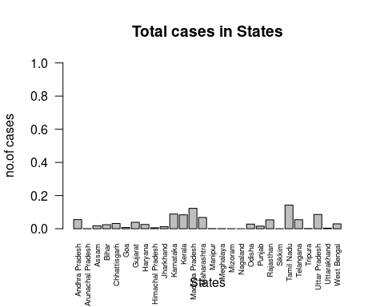

#Subset of Cities  
ds2=filter(ds,Category=="City")  
  
#Histograms for Cities  
histogram(~Total...Cases,data=ds2,breaks = 50)

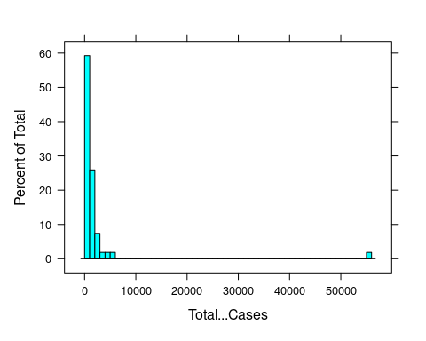

histogram(~Total...Injured,data=ds2,breaks = 50)

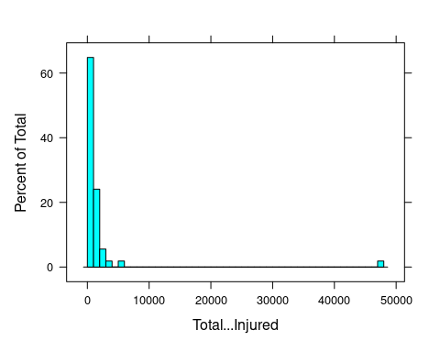

histogram(~Total...Died,data=ds2,breaks=50)

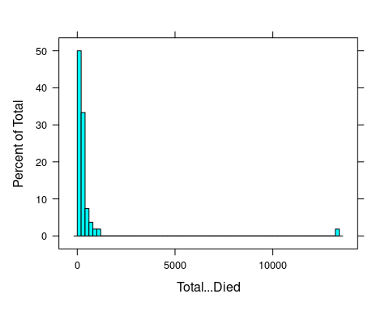

#Barplot for Cities  
bp2=ds2[-c(54), ]  
  
names(bp2)

## [1] "Category" "State.UT.City"   
## [3] "National.Highways...Cases" "National.Highways...Injured"  
## [5] "National.Highways...Died" "State.Highways...Cases"   
## [7] "State.Highways...Injured" "State.Highways...Died"   
## [9] "Expressways...Cases" "Expressways...Injured"   
## [11] "Expressways...Died" "Other.Roads...Cases"   
## [13] "Other.Roads...Injured" "Other.Roads...Died"   
## [15] "Total...Cases" "Total...Injured"   
## [17] "Total...Died"

barplot(bp2$Total...Cases,  
 ylim = c(0,60000),  
 names.arg = bp2$ State.UT.City,  
 las = 2,cex.names =0.6,main="Total cases in Cities",  
 xlab = "Cities",ylab = "no.of cases")

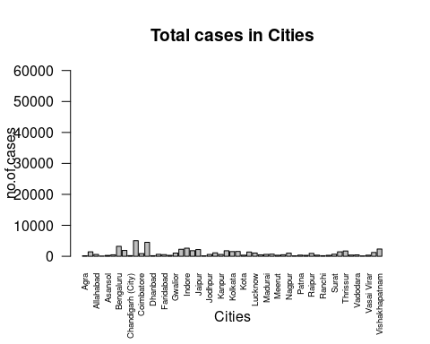

#Subset of Union Territories  
ds3=filter(ds,Category=="UT")  
   
#Histograms for Union Territories  
histogram(~Total...Cases,data=ds3,breaks = 50)

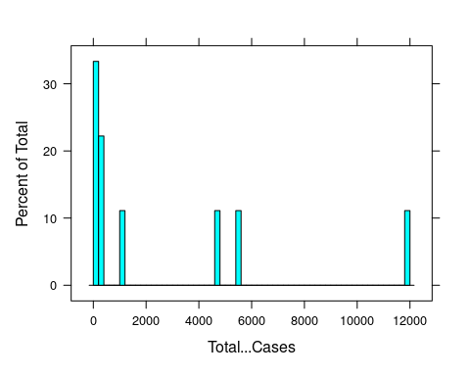

histogram(~Total...Injured,data=ds3,breaks = 50)

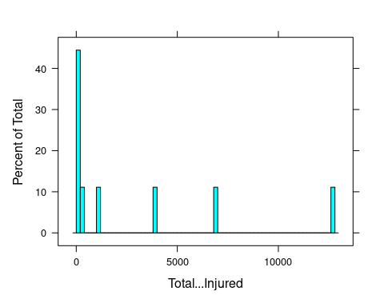

histogram(~Total...Died,data=ds3,breaks=50)

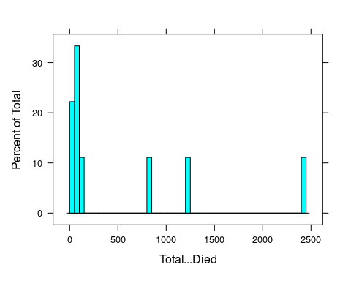

#Barplot for Union Territories  
bp3=ds3[-c(9), ]  
names(bp3)

## [1] "Category" "State.UT.City"   
## [3] "National.Highways...Cases" "National.Highways...Injured"  
## [5] "National.Highways...Died" "State.Highways...Cases"   
## [7] "State.Highways...Injured" "State.Highways...Died"   
## [9] "Expressways...Cases" "Expressways...Injured"   
## [11] "Expressways...Died" "Other.Roads...Cases"   
## [13] "Other.Roads...Injured" "Other.Roads...Died"   
## [15] "Total...Cases" "Total...Injured"   
## [17] "Total...Died"

barplot(bp3$Total...Cases,  
 ylim = c(0,12000),  
 names.arg = bp3$ State.UT.City,  
 las = 2,cex.names =0.6,main="Total cases in UT",  
 xlab = "UT",ylab = "no.of cases")

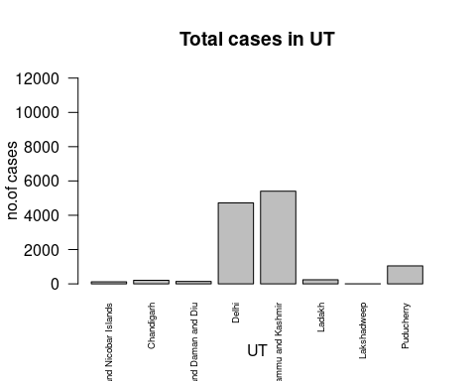

#EDA for Accidents in Highways  
bp1=mutate(bp1,Highways_cases=National.Highways...Cases+State.Highways...Cases  
 +Expressways...Cases)  
  
  
bp2=mutate(bp2,Highways_cases=National.Highways...Cases+State.Highways...Cases  
 +Expressways...Cases)  
  
  
bp3=mutate(bp3,Highways_cases=National.Highways...Cases+State.Highways...Cases  
 +Expressways...Cases)  
  
#Histograms for the cases in Highways  
histogram(~Highways_cases,data=bp3,main="Highways cases in Union territories",breaks=50)

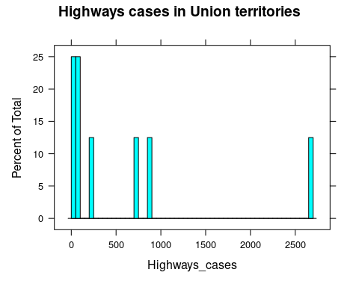

histogram(~Highways_cases,data=bp2,main="Highways cases in Cities",breaks=50)

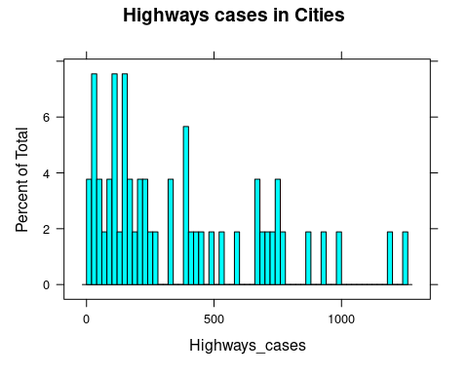

histogram(~Highways_cases,data=bp1,main="Highways cases in States",breaks=50)

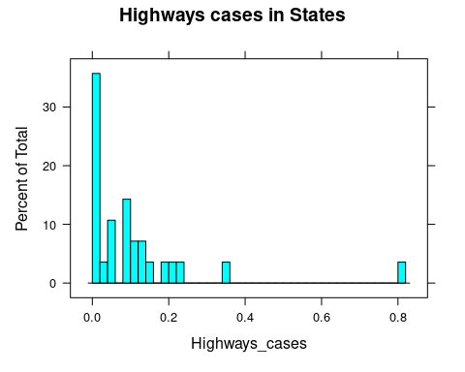

#Box plots for Death cases   
bwplot(State.UT.City=="Tamil Nadu"& Highways_cases~Total...Died,data=bp1,main="Number of death cases",  
 xlab="Cases",ylab="No of deaths",col="green")

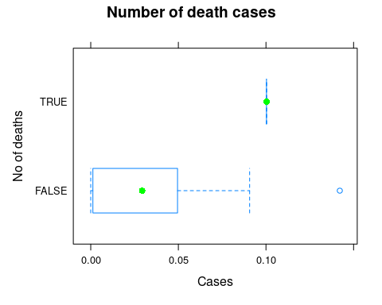

bwplot(State.UT.City=="Chennai"& Highways_cases~Total...Died,data=bp2,main="Number of death cases",  
 xlab="Cases",ylab="No of deaths",col="red")

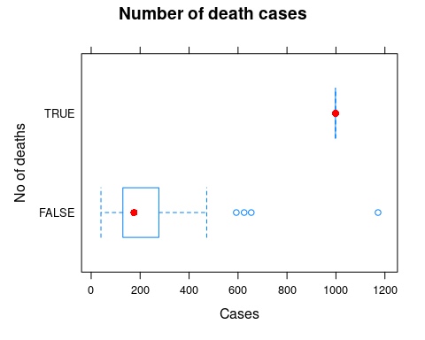

bwplot(State.UT.City=="Jammu and Kashmir"& Highways_cases~Total...Died,data=bp3,main="Number of death cases in highways",  
 xlab="No of Cases",ylab="No of deaths",col="blue")

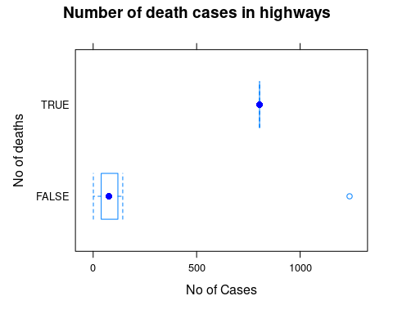

#Box plots for Injured Cases  
bwplot(State.UT.City=="Tamil Nadu"& Highways_cases~Total...Injured,data=bp1,main="Number of injured cases",  
 xlab="Cases",ylab="No of injured",col="green")

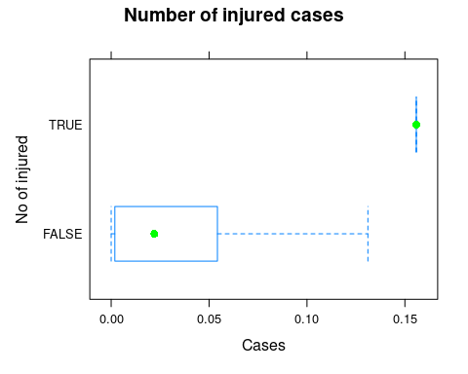

bwplot(State.UT.City=="Chennai"& Highways_cases~Total...Injured,data=bp2,main="Number of injured cases",  
 xlab="Cases",ylab="No of injured",col="red")

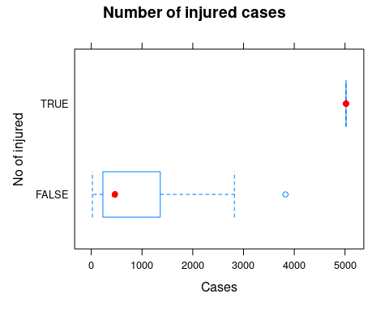

bwplot(State.UT.City=="Jammu and Kashmir"& Highways_cases~Total...Injured,data=bp3,main="Number of injured cases",  
 xlab="No of Cases",ylab="No of injured",col="blue")

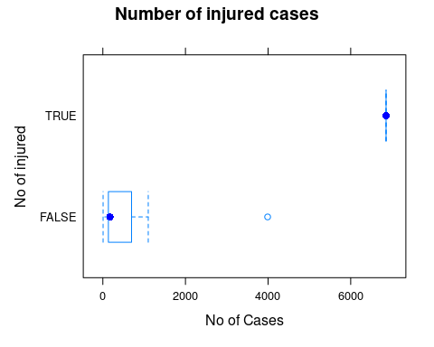

#Scatter plots for Highways cases & deaths  
  
#Scatter plot for States  
#Cases  
sp1 <- bp1[,c("Total...Cases","Highways_cases")]  
plot(x= sp1$Total...Cases,y=sp1$Highways_cases,  
 xlab= "Total cases",  
 ylab="Highways cases",  
 xlim=c(0,0.16),  
 ylim=c(0,0.9),  
 main="Highways cases in States")

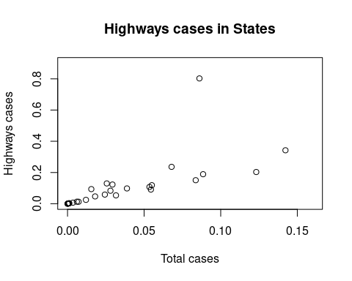

cor(sp1$Total...Cases,sp1$Highways_cases)

## [1] 0.6895354

#Deaths  
sp1d <- bp1[,c("Highways_cases","Total...Died")]  
plot(x= sp1d$Highways_cases,y=sp1d$Total...Died,  
 xlab= "Highways cases",  
 ylab="Total died",  
 xlim=c(0,0.9),  
 ylim=c(0,0.16),  
 main="Highways deaths in States")

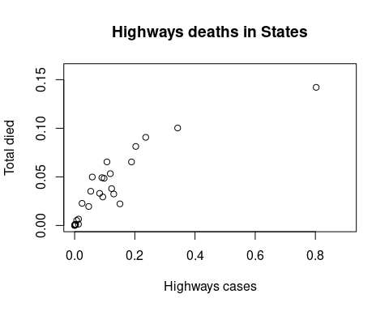

cor(sp1d$Highways_cases,sp1d$Total...Died)

## [1] 0.8832092

#Scatter plot for Cities  
#Cases  
sp2 <- bp2[,c("Total...Cases","Highways_cases")]  
plot(x= sp2$Total...Cases,y=sp2$Highways_cases,  
 xlab= "Total cases",  
 ylab="Highways cases",  
 xlim=c(0,6000),  
 ylim=c(0,1400),  
 main="Highways Cases in Cities")

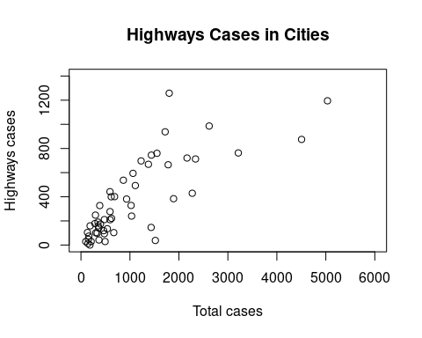

cor(sp2$Total...Cases,sp2$Highways_cases)

## [1] 0.7907479

#Deaths  
sp2d <- bp2[,c("Highways_cases","Total...Died")]  
plot(x= sp2d$Highways_cases,y=sp2d$Total...Died,  
 xlab= "Highways cases",  
 ylab="Total died",  
 xlim=c(0,1400),  
 ylim=c(0,1200),  
 main="Highways deaths in Cities")

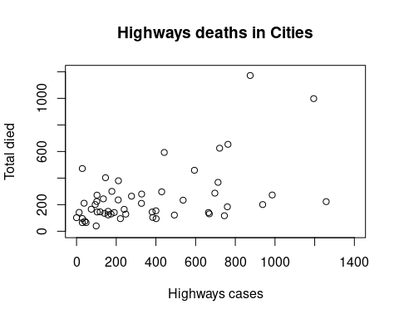

cor(sp2d$Highways_cases,sp2d$Total...Died)

## [1] 0.4945743

#Scatter plot for Union Territories  
#Cases  
sp3 <- bp3[,c("Total...Cases","Highways_cases")]  
plot(x= sp3$Total...Cases,y=sp3$Highways_cases,  
 xlab= "Total cases",  
 ylab="Highways cases",  
 xlim=c(0,6000),  
 ylim=c(0,3000),  
 main="Highways cases in Union territories")

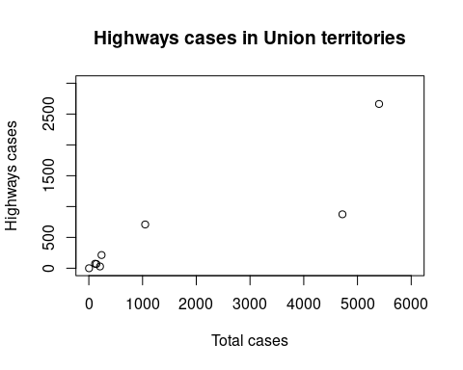

cor(sp3$Total...Cases,sp3$Highways_cases)

## [1] 0.8784569

#Deaths  
sp3d <- bp3[,c("Highways_cases","Total...Died")]  
plot(x= sp3d$Highways_cases,y=sp3d$Total...Died,  
 xlab= "Highways cases",  
 ylab="Total died",  
 xlim=c(0,3000),  
 ylim=c(0,1500),  
 main="Highways deaths in UT")

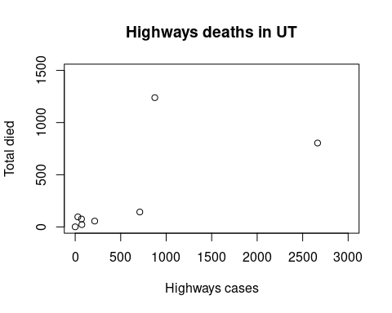

cor(sp3d$Highways_cases,sp3d$Total...Died)

## [1] 0.6651939

#EDA for Accidents in Other roads  
#Histograms for the cases in Other roads  
histogram(~Other.Roads...Cases,data=bp3,main="Other roads cases in Union territories",breaks=50)

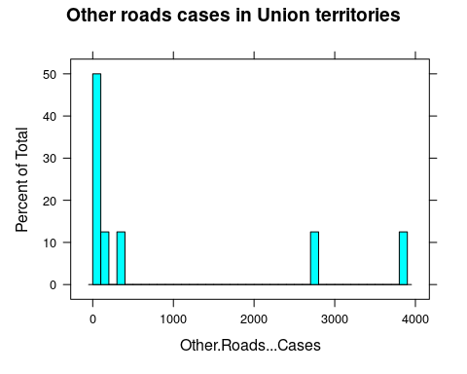

histogram(~Other.Roads...Cases,data=bp2,main="Other roads cases in Cities",breaks=50)

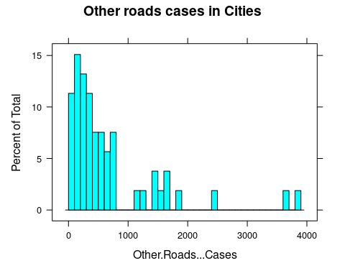

histogram(~Other.Roads...Cases,data=bp1,main="Other roads cases in States",breaks=50)

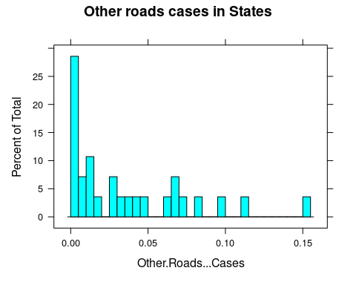

#Box plots for Death cases   
bwplot(State.UT.City=="Tamil Nadu"& Other.Roads...Cases~Total...Died,data=bp1,main="Number of death cases",  
 xlab="Cases",ylab="No of deaths",col="green")



bwplot(State.UT.City=="Chennai"&Other.Roads...Cases ~Total...Died,data=bp2,main="Number of death cases",  
 xlab="Cases",ylab="No of deaths",col="red")



bwplot(State.UT.City=="Jammu and Kashmir"& Other.Roads...Cases~Total...Died,data=bp3,main="Number of death cases",  
 xlab="No of Cases",ylab="No of deaths",col="blue")

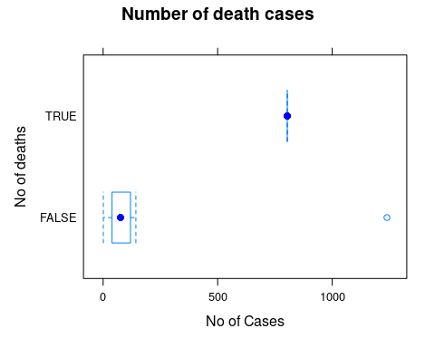

#Box plots for Injured Cases  
bwplot(State.UT.City=="Tamil Nadu"&Other.Roads...Cases ~Total...Injured,data=bp1,main="Number of injured cases",  
 xlab="Cases",ylab="No of injured",col="green")



bwplot(State.UT.City=="Chennai"&Other.Roads...Cases ~Total...Injured,data=bp2,main="Number of injured cases",  
 xlab="Cases",ylab="No of injured",col="red")



bwplot(State.UT.City=="Jammu and Kashmir"& Other.Roads...Cases~Total...Injured,data=bp3,main="Number of injured cases",  
 xlab="No of Cases",ylab="No of injured",col="blue")



#Scatter plots for Other roads cases & deaths  
  
#Scatter plot for States  
#Cases  
spo1 <- bp1[,c("Total...Cases","Other.Roads...Cases")]  
plot(x= spo1$Total...Cases,y=spo1$Other.Roads...Cases,  
 xlab= "Total cases",  
 ylab="Other roads cases",  
 xlim=c(0,0.16),  
 ylim=c(0,0.16),  
 main="Other roads cases in States")

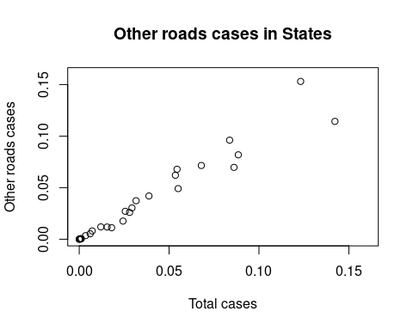

cor(spo1$Total...Cases,spo1$Other.Roads...Cases)

## [1] 0.9699067

#Deaths  
spo1d <- bp1[,c("Other.Roads...Cases","Other.Roads...Died")]  
plot(x= spo1d$Other.Roads...Cases,y=spo1d$Other.Roads...Died,  
 xlab= "Other Roads Cases",  
 ylab="Other Roads Died",  
 xlim=c(0,0.16),  
 ylim=c(0,0.14),  
 main="Other roads deaths in States")

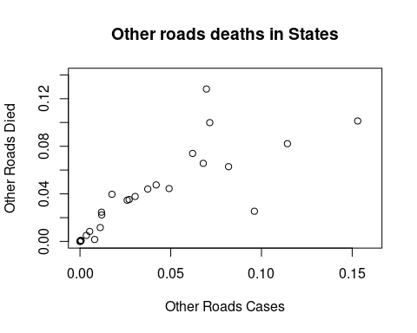

cor(spo1d$Other.Roads...Cases,spo1d$Other.Roads...Died)

## [1] 0.8209134

#Scatter plot for Cities  
#Cases  
spo2 <- bp2[,c("Total...Cases","Other.Roads...Cases")]  
plot(x= spo2$Total...Cases,y=spo2$Other.Roads...Cases,  
 xlab= "Total cases",  
 ylab="Other.Roads...Cases",  
 xlim=c(0,6000),  
 ylim=c(0,4000),  
 main="Other roads Cases in Cities")

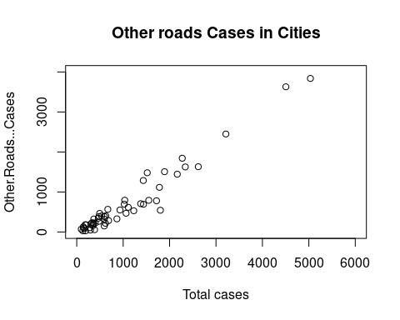

cor(spo2$Total...Cases,spo2$Other.Roads...Cases)

## [1] 0.970083

#Deaths  
spo2d <- bp2[,c("Other.Roads...Cases","Other.Roads...Died")]  
plot(x= spo2d$Other.Roads...Cases,y=spo2d$Other.Roads...Died,  
 xlab= "Other roads cases",  
 ylab="Other roads died",  
 xlim=c(0,4000),  
 ylim=c(0,900),  
 main="Other roads deaths in Cities")

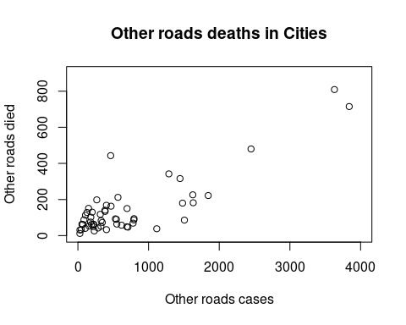

cor(spo2d$Other.Roads...Cases,spo2d$Other.Roads...Died)

## [1] 0.8350358

#Scatter plot for Union Territories  
#Cases  
spo3 <- bp3[,c("Total...Cases","Other.Roads...Cases")]  
plot(x= spo3$Total...Cases,y=spo3$Other.Roads...Cases,  
 xlab= "Total cases",  
 ylab="Other Roads Cases",  
 xlim=c(0,6000),  
 ylim=c(0,4000),  
 main="Other Roads cases in Union territories")

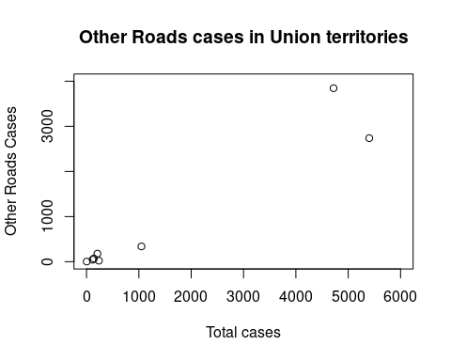

cor(spo3$Total...Cases,spo3$Other.Roads...Cases)

## [1] 0.9578484

#Deaths  
spo3d <- bp3[,c("Other.Roads...Cases","Other.Roads...Died")]  
plot(x= spo3d$Other.Roads...Cases,y=spo3d$Other.Roads...Died,  
 xlab= "Other Roads Cases",  
 ylab="Other.Roads Died",  
 xlim=c(0,4000),  
 ylim=c(0,1000),  
 main="Other roads deaths in UT")

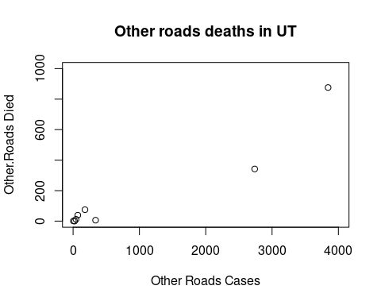

cor(spo3d$Other.Roads...Cases,spo3d$Other.Roads...Died)

## [1] 0.9551562